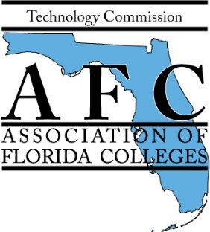

AFC TECHNOLOGY COMMISSION 2022 EXEMPLARY PRACTICE AWARDS

“LEGACY: The key to Reflection, Inclusion, and Reconnection.”

Theme: "Technology in Leadership"

Main Idea: “Practices that prepare students with skills needed for tech jobs in the community”
Nomination Form

Complete and submit this form with a brief written summary (not to exceed 1, 000 words) and any supporting documentation to the committee by 5:00 p.m. Friday, August 5, 2022.

Title of Nominee's Project:
Nominee’s Name: _____ ___
Nominee's College: Campus: __ ___
Nominee’s E-Mail:
Are you able to present at the 2022 Fall Annual Conference in November? __ ____
Reason for nomination: Attach a brief summary (not to exceed 1,000 words) about the project, including information that supports the criteria listed on the judging criteria page. Include any supporting documentation.

Submission deadline: Friday, August 5, 2022 by 5:00 p.m.

Submit nomination form, a brief summary, video (large videos may be sent in the form of a link), and supporting documentation electronically email to: jbeck@pensacolastate.edu
cc: bcabrera@mdc.edu

AFC TECHNOLOGY COMMISSION
Exemplary Practice Awards

“LEGACY: The key to Reflection, Inclusion, and Reconnection.”
Judging Criteria and Scoring Rubric

Theme: "Technology in Leadership"

Main Idea: “Practices that prepare students with skills needed for tech jobs in the community”

PURPOSE

The mission of the Technology Commission is to represent the interests of Florida's community and state college personnel whose job interests include technology-related activities or issues. The Technology Commission strives to enhance student learning, improve institutional effectiveness, and promote effective participation in all aspects of technology management, planning, information sharing, eLearning, and innovation.

Nominee’s Name: _

Nominee's Institution:

Title of Nominee's Practice:

Nominee’s Total Points:

CRITERIA DESCRIPTION | Possible Points | Earned Points
PURPOSE | (50)
Degree that practice supports the mission of Florida College System and the Association of Florida Colleges.  List documents provided supporting this criteria. | 10
Degree that practice supports student learning.  List documents provided supporting this criteria. | 20
Justifies key results and procedures, explains assumptions and reasons.  List documents provided supporting this criteria. | 20
EXEMPLARY CRITERIA | (50)
Adaptability of idea – Can others easily adopt and adapt the project?  List documents provided supporting this criteria | 5
Illustrative quality of support materials – How well do the support materials demonstrate or explain the project?  List documents provided supporting this criteria. | 5
Accountability/assessment of practice – Is there evidence that the practice is measurably making a difference?  List documents provided supporting this criteria | 20
Innovation or originality of idea.  List documents provided supporting this criteria. | 10
Recommendations by student(s), colleague(s) or faculty included that confirms or verifies that practice makes a difference/meets criteria (emails, notes, or formal letters).  List documents provided supporting this criteria. | 10
TOTAL POINTS | 100 | Individual tally  Average tally

