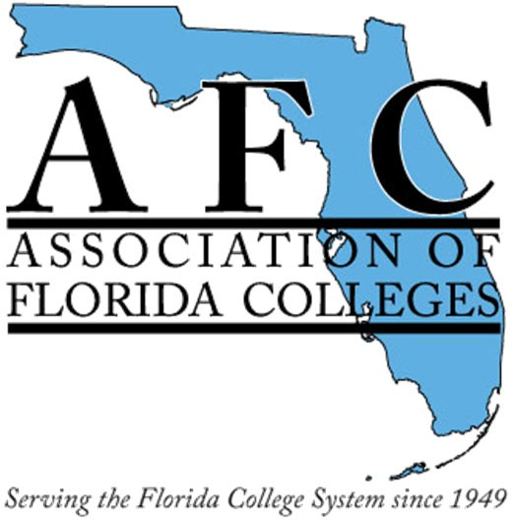

Commission Name: Technology Commission
Submitted by: Dr. Belkis L. Cabrera Reporting Period: October 2023-December 2023
Date Submitted/Due: 1/30/2024

Membership & Meetings
Commission Executive Board Meetings (Number of meetings held):
- 5 meetings: 1.25.2023, 6.15.2023, 7.15.2023, 11.1.2023 & 12.13.2023.

General Membership Meetings (Number of meetings held):
- 5 meetings: 1.25.2023, 6.15.2023, 7.15.2023, 11.1.2023 & 12.13.2023.

Number Of New Members (List names if available):
- 128 total additions last reported 137 a decrease of 9 members as per AFC online list.

Other: (Ex: By‐laws updates, changes in Commission leadership, etc.)
- By-laws updated May 31, 2023 changes updates submitted to Eilleen.
2024 EXECUTIVE BOARD
Chair: Dr. Belkis L. Cabrera, Miami Dade College-Padron, eMail: bcabrer2@mdc.edu;
Phone: 305-237-6818 Officer attending conferences and events.
Past Chair: Jamie Beck, Pensacola State College, eMail: jbeck@pensacolastate.edu; Phone: 850-484-1513 Acting as Consultant of the AFC Technology Commission.
Webmaster: Pamela Suguimitzu, Miami Dade College-Padron, eMail: psuguimi@mdc.edu;
Phone: 305-237-6343 In charge of managing social media accounts including creating a few blog posts related to tech and Higher Ed. Updating the WiX website (psuguimi.wixsite.com)
Treasurer: Sheri Thomas, Tallahassee Community College, sheri.thomas@tcc.fl.edu; Phone: 850-201-6188
Managing the financial budget and fundraising affairs.
Historian: Kim Castle, Eastern Florida State College, eMail: castlek@easternflorida.edu Phone: 321-433-5553 - Collecting and archiving photos, flyers, and records for the Yearbook.
Secretary: Bertha Cabrera, Miami Dade College-North, eMail: bcabrera@mdc.edu; Phone: 305-237-8115.
Preparing agenda minutes, events, schedules, announcements, PDF proposals, and Weebly/district websites.
​Honorary member-Special Guest: Jessie Clayton, Tallahassee Community College, eMail: jessie.claytonj@tcc.fl.edu; Phone: 850-201-8267 attendance optional

Activities
Legislative Advocacy Activities (Number and type hosted):
- https://www.myafchome.org/afc-advocacy-toolkit
- https://www.myafchome.org/assets/Advocacy_Policy/legislative%20issue%20req%20form.pdf 2 online postings and social media directing impact of legislative issues.
- 2 Reading and advertising of Current and Capitol Perceptions updates.
- Total 4 Legislative Advocacy Activities and Discussions.
Professional Development Activities (Number and type hosted):
- 4 PDs - 2 PDs on Instructional Design and Libguide vs Weebly @ Region I
1 PD Annual Conference Exemplary Practice: “At The Vanguard Of Change - How One HIS Navigates This Next Evolution In Education Through Course Redesign & Technology.” How Learning Works virtual on March 30th, 2023 by WeLearn366 Director Dr. Belkis L. Cabrera.
Social Activities (Number and type hosted):
- 1 Social Activity at Annual Conference Cheesecake dinner in Orlando.
Membership Development Activities (Number and type hosted):
- 5 MD Activities: Adobe Halloween Contest and 4 PD workshops.
Fundraising Activities (Number and type hosted):
- 3 items donated to the Annual Conference Silent Auction.
Executive Board of Directors Attendance
https://indd.adobe.com/view/publication/64f58106-3f26-4b2b-a4a5-37f4b7e255d8/1/publication-web-resources/image/293.svgz

Partnerships
Participation in Events & Activities with State, Regions, or Other Commissions:
- AFC Region V, AFC MDC Chapter, WeLearn366 Institute, Region I conference and presentation, Annual Conference in Orlando, Executive Board Directors Meetings, Faculty Commission, and AFC Membership Development Committee.
Other Announcements
- Launched Wix website https://psuguimi.wixsite.com/afctechnologycommiss
- Offering PDs (supporting our local community with 3 Tech Talks per term), a goal on garnering exemplary award submissions (maybe we can create an ad campaign and aim for at least 5 submissions), a goal for presenting at conferences (sharing with scholarly community at least once per year), and a membership goal (increasing commission membership by 10).

