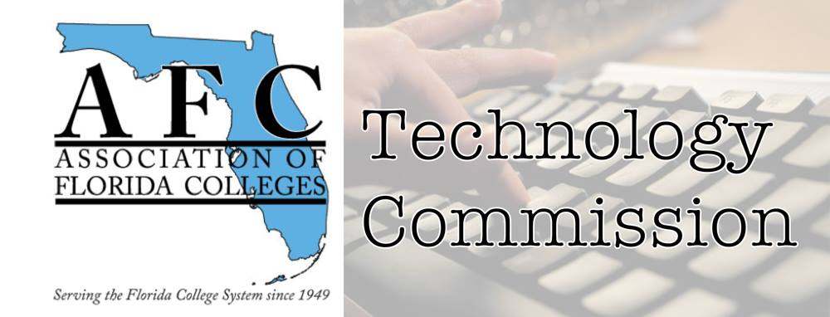
AFC Technology Commission
Presenter Form

Conference Type: Leave Blank
Date: Leave Blank
Time slot: Leave Blank.
Location: Leave Blank

Name of presenter(s) and Job Title(s): Bertha Cabrera, Academic Advisor
Contact Information email/phone: bcabrera@mdc.edu 305-237-8468
Abstract of presentation (150 words or less): https://libraryguides.mdc.edu/eapservices
The libguide is a website available through the library system. Using the libguide allows me to present to MDC students information that they need in a day-to-day basis. This libguide has templates that we can easily adapt to what we want to showcase in the format and order that best suits our needs. A libguide https://libraryguides.mdc.edu/ at MDC has editors assigned working with you to update and present the data based on their knowledge and expertise.
Bio of Presenter(s) (100 words or less): Bertha Cabrera graduated with a BAS in Supervision & Management from Miami Dade College, and a Bachelor’s in Chemistry from the University of Havana, Cuba. Bertha is trained in the use of Office 365 in addition to Oracle People Soft operations and software, Nearpod, Kahoot, SparkAdobe, Weebly, Blackboard, CANVA, Zoom, Teams, Respondus, Qualtrics, Panopto, OneNote, and Jamboard. She is responsible, organized, creative, and targeted oriented. She is the Secretary of the Technology Commission with a zest for new technology trends, programs, and applications.

Technology needs (laptop, audiovisual equipment, etc.):
Laptop and projector – Zoom

