AFC COMMISSIONS’ REPORT
Commission: Technology  Submitted by: Jamie Beck and Bertha Cabrera  Reporting Period: October 2022 - December 2022  Date Submitted/Due: _____1/25/2023_________ | 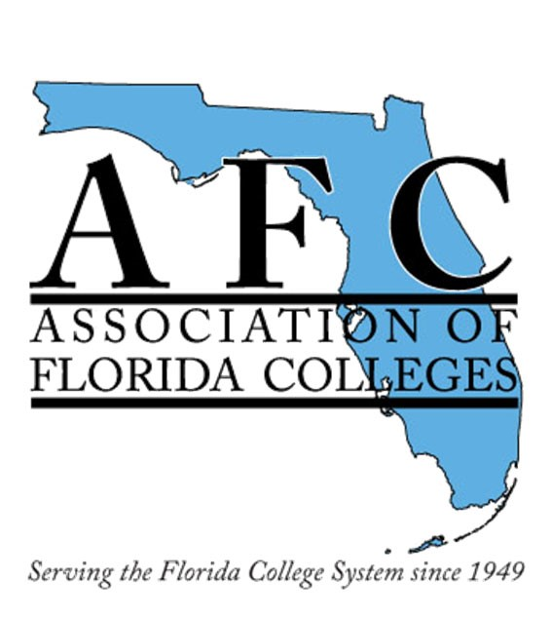

Commission Administration, Membership & Meetings
# of Members: First commission 137 members.
Technology Commission Board Members:
- Chair – Jamie Beck (Pensacola State College)
- Chair-Elect – Dr. Belkis L. Cabrera (Miami Dade College)
- Past Chair Jessie Clayton (Tallahassee Community College)
- Webmaster – Eleazar Asencio (Miami Dade College)
- Treasurer – Sheri Thomas (Tallahassee Community College)
- Historian Jacqueline Edwards (Tallahassee Community College)
- Secretary– Bertha Cabrera (Miami Dade College)
- Commission Board Meetings: postpone for 2023
Participation in Events & Activities

Commission Activities:
  - Technology Commission Exemplary Practice:
Kevin Moreau, Program Grant Manager
Palm Beach State College, Boca Raton campus – Presentation Title: PBSC tresPATHS Grant

  - Outstanding Commission of the Year Award
Technology Commission won for the second consecutive year.
- Tallahassee Community College
Unsung Hero Award
Jessie Clayton, past chair of the Technology Commission

- Long Term Goals:
- Increase active membership in the Technology Commission selection.
- Review, update, and submit Technology Commission Operational Plan based on the Commission of the Year criteria.

Budget Report: AFC Technology Commission Budget $2,216.52 as of 8/2/2022.

State, Region & Commission Participation

Participation in the 73rd Annual Conference by Jamie Beck, Chair of the Technology Commission

Other Updates: Websites: Commission - Weebly – social media updates https://www.myafchome.org/technologycommission

https://afctechnologycommission.weebly.com/

