AFC COMMISSIONS’ REPORT
Commission: Technology  Submitted by: Jamie Beck and Bertha Cabrera  Reporting Period: _July 2022 – October 2022_____  Date Submitted/Due: _____11/14/2022_________ | 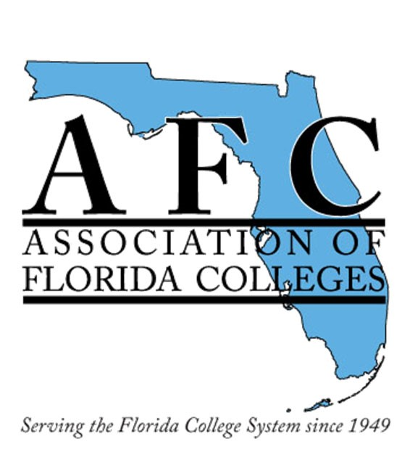

Commission Administration, Membership & Meetings
Commission Board Meetings: Selection of the Award Winner for the exemplary practice award.
General Membership Meetings: August 31, 2022, online meeting.
# of New Members: First commission 138 members.
Other: By-laws updated May 29, 2022.

Commission Activities
Activities by Commission: Awarded exemplary practice award to Kevin Moreau at Palm Beach State College.
Call for donations: to the Red Cross for Hurricanes Fiona & Ian disaster’s zones.
Professional Development Activities by Commission: Presentations during Region I (Libguide/Padlet), and in person September 19, 2022 – MDC North, Miami, Florida.

AFC COMMISSION REPORT
Social Activities by Commission: 2022 Halloween Contest using Adobe Express.
Membership Development Activities by Commission: Celebration flyers with link to “Join Us” for Memorial Day, Independence Day, Labor Day, Hispanic Day.
Fundraising Activities by Commission: Call for donations to the Silent Auction.

State, Region & Commission Participation
Participation in Events & Activities (Ex: conferences, commission events, Access AFC, professional development, AFC state region and/or commission webinars) Region I and Webinars – Added Pinterest to social media.
Ongoing Tutorials: https://afctechnologycommission.weebly.com/uploads/5/4/3/7/54376519/preview_of_trainings_berthacabrera.pdf

Other Updates: Websites: Commission - Weebly – Social Media https://www.myafchome.org/technologycommission

https://afctechnologycommission.weebly.com/

