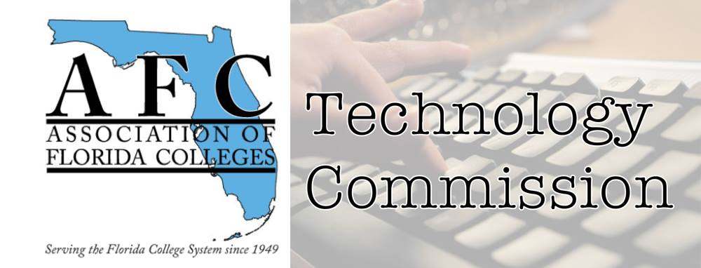
AFC Technology Commission
Presenter Form
(PROPOSAL)
Conference Type: Region I
Date: March 31, 2023
Time slot: TBA
Location: Chipola College

Name of presenter(s) and Job Title(s):
Belkis L. Cabrera, Ph.D. Project Director, WeLearn 366 Institute, Miami Dade College - Padrón Campus

Contact Information email/phone:
E: bcabrer2@mdc.edu/T: (305) 237-6818

Abstract of presentation (150 words or less):
Not Your Grandmother's ID: Exploring the Elusive and Ubiquitous Science of Instructional Design Through a Personal Journey
Are you ready for the meta-version of Instructional Design? The field of ID has morphed and continues to morph over the past decade with the last five years representing a tremendous leap. To date, there are countless definitions, systems, structures, and programs encapsulated in ID. From education to business, from technologist to professional developer, the realm of the ID expert is vast and varied. Although there is some truth and validity in Wagner's (2011) argument about the secret handshakes of IDs, there is no denying that it has become increasingly difficult to recognize and explain the work and the skillsets of today's instructional designers. In this workshop, we will briefly examine the history of ID, explore definitions and terminology, and engage in conversations about the future of this elusive field/science/reality. We will also share our own ID journeys and our insights for building programs that effectively prepare the next generation of IDs.
Bio of Presenter(s) (100 words or less):
Dr. Belkis L. Cabrera is a teacher, mentor, consultant, and professional development facilitator, who has worked with over 100+ institutions and organizations on education reform and educational equity. She has an M.A. in English and a Ph.D. in Instructional Design and Technology. Most recently, she served as Instructional Consultant for FIU’s Center for the Advancement of Teaching, where she worked across departments and campuses to redesign 21 critical high enrollment, high failure (or high impact) courses. Presently, Dr. Cabrera leads the WeLearn366 Institute at Miami-Dade College’s Padron Campus.
Technology needs (laptop, audiovisual equipment, etc.):
Laptop and projector

