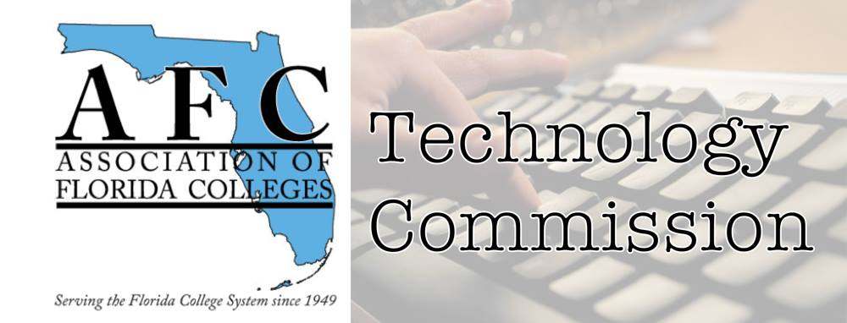
AFC Technology Commission
Presenter Form

Conference Type: Leave Blank
Date: Leave Blank
Time slot: Leave Blank.
Location: Leave Blank

Name of presenter(s) and Job Title(s):

Contact Information email/phone:

Abstract of presentation (150 words or less):

Bio of Presenter(s) (100 words or less):

Technology needs (laptop, audiovisual equipment, etc.):
Laptop and projector

