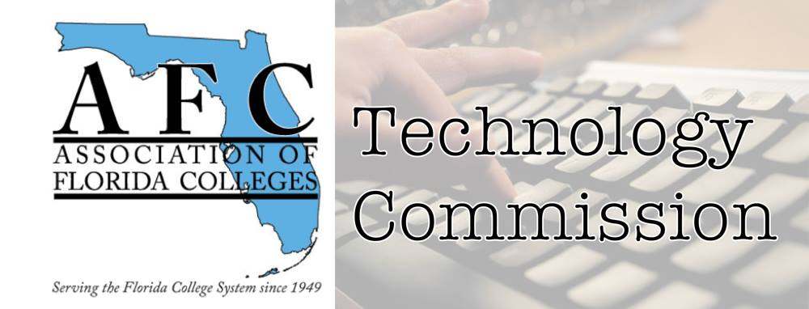
AFC Technology Commission
Presenter Form

Conference Type: Region I
Date: March 31, 2023
Time slot: TBA
Location: Chipola College

Name of presenter(s) and Job Title(s):
Bertha Cabrera, Academic Advisor
Contact Information email/phone:
Miami Dade College North Campus
bcabrera@mdc.edu / 305-237-8161
Abstract of presentation (150 words or less): A Weebly Website vs. a LibGuide Website
The LibGuide is a website available through the library system. Weebly website builder is a platform that we can use for marketing purposes. Like the libguide, Weebly has templates that we can easily adapt to what we want to showcase. A perfect example is the link to the AFC Technology Commission at AFC Technology Commission - AFC Commission of the YEAR 2023 (weebly.com)
We can duplicate the page, create a new page, import images, YouTube videos, and more with a free version…for a premium rate you can add other available features to enhance your website.
Bio of Presenter(s) (100 words or less):
Bertha Cabrera graduated with a BAS in Supervision & Management from Miami Dade College, and a Bachelor’s in Chemistry from the University of Havana, Cuba. Bertha is trained in the use of Office 365 in addition to Oracle People Soft operations and software, Nearpod, Kahoot, SparkAdobe, Weebly, Blackboard, CANVAS, Zoom, Teams, Respondus, Qualtrics, Panopto, OneNote, and Jamboard. She is responsible, organized, creative, and targeted oriented. She is the Secretary of the Technology Commission with an endless zest for new technology trends, programs, and applications.
Technology needs (laptop, audiovisual equipment, etc.):
Laptop and projector

