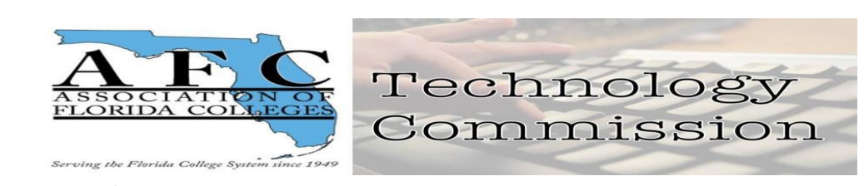

AFC Technology Commission Executive Board Report

July 13, 2023
Technology Commission Board Members:
1. Chair – Jamie Beck (Pensacola State College)
2. Chair-Elect – Dr. Belkis L. Cabrera (Miami Dade College)
3. Past Chair - Jessie Clayton (Tallahassee Community College)
4. Webmaster – Pamela Suguimitzu (Miami Dade College)
5. Treasurer – Sheri Thomas (Tallahassee Community College)
6. Historian - Vacant
7. Secretary – Bertha Cabrera (Miami Dade College-West)
- The Exemplary Practice Award: Exemplary Practice Award Theme: "Moving Forward to Creative & Innovative ways of using Technology in
Education" a submission via email was received from MDC Padron Campus
https://libraryguides.mdc.edu/WeLearn
- Professional Development Series: The PD Lunch & Learn Series (see PP presentation proposal) will be promoted on CANVAS first page of AFC Technology Commission Weebly Website.
- A proposal for the AFC Technology Commission of the year posted online
https://afctechnologycommission.weebly.com/proposal-for-the-afc-commission-of-the-year-2023.html
- Historian Position: A new member to AFC at MDC is a candidate for the position subject to review and approval from the board members.
- Leadership Volunteers:
AFC Membership Committee members: Jessie Clayton, past chair of the Technology Commission, and Bertha Cabrera, Secretary volunteered to serve as liaisons to boost membership attending meetings and participating in projects.
- Fundraising efforts: Ongoing request for donation of items for the AFC Auction
Received items from donor Bertha Cabrera pictures will be posted online.
- Communication Goals:
Newsletter and brochure updates.
AFC Technology Commission Circle with 13 members enrolled.
- Social Activities:
Going-on Adobe Express Contest. Social Media presence Twitter, Facebook, LinkedIn, Pinterest (new addition), Instagram.
- Long Term Goals: Continue promoting participation in the Technology Commission, fill in Historian vacant position, and bring innovation and creativity to the technology field including AI applications.

