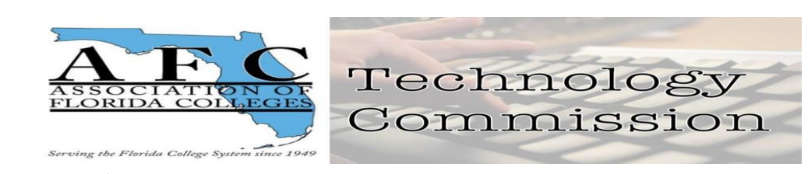

AFC Technology Commission Executive Board Report

October 4, 2023
Technology Commission Board Members:
1. Chair – Jamie Beck (Pensacola State College)
2. Chair-Elect – Dr. Belkis L. Cabrera (Miami Dade College)
3. Past Chair - Jessie Clayton (Tallahassee Community College)
4. Webmaster – Pamela Suguimitzu (Miami Dade College)
5. Treasurer – Sheri Thomas (Tallahassee Community College)
6. Historian - Vacant
7. Secretary – Bertha Cabrera (Miami Dade College-North)
- The commission board members voted for first and second place award winners for the Exemplary Practice Award: Exemplary Practice Award. There were two submissions. Board members who submitted proposals did not vote.
Results of the Awards are posted on our website at Technology Commission (myafchome.org)
- Historian Position: TBA
- Leadership Volunteers: Jessie Clayton, past-chair volunteered to work with the AFC Membership Committee along with Bertha Cabrera, Secretary.
- Fundraising efforts: Ongoing request for donation of items for the AFC Auction
Received items from donor Bertha Cabrera pictures will be posted online.
See the link for the Auction and/or our Local Weebly website: AFC Technology Commission - Proposal for the AFC Commission of the YEAR 2023 (weebly.com)
- Communication Goals: We expanded our social media platform to include Pinterest in addition to LinkedIn, Twitter, Instagram and AFC Circle postings.
Newsletter and brochure updates online at https://view.officeapps.live.com/op/view.aspx?src=https%3A%2F%2Fafctechnologycommission.weebly.com%2Fuploads%2F5%2F4%2F3%2F7%2F54376519%2F2023newsletter.pptx&wdOrigin=BROWSELINK and implementing a blog tab on Wix.
- Social Activities: Going-on Adobe Express Contest. Social Media presence Twitter, Facebook, LinkedIn, Pinterest (new addition), Instagram. Joining Region V and MDC Chapter on their social activities see pictures on
https://libraryguides.mdc.edu/Association_of_Florida_Colleges
- Long Term Goals: Continue promoting participation in the Technology Commission, fill in Historian vacant position, and bring innovation and creativity to the technology field including AI applications. Technology brings people together!

