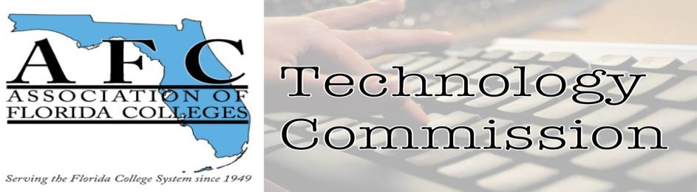

Technology Commission Board Report
Reporting period: July 2022 - December 2022
Jan. 25, 2023
Submitted by Jamie Beck

Technology Commission Board Members:
- Chair – Jamie Beck (Pensacola State College)
- Chair-Elect – Dr. Belkis L. Cabrera (Miami Dade College)
- Past Chair Jessie Clayton (Tallahassee Community College)
- Webmaster – Eleazar Asencio (Miami Dade College)
- Treasurer – Sheri Thomas (Tallahassee Community College)
- Historian Jacqueline Edwards (Tallahassee Community College)
- Secretary– Bertha Cabrera (Miami Dade College)

- Commission Board Meetings: July 5, 2022 & August 31, 2022
  - Technology Commission Exemplary Practice:
Kevin Moreau, Program Grant Manager
Palm Beach State College, Boca Raton campus – Presentation Title: PBSC tresPATHS Grant

  - Outstanding Commission of the Year Award
Technology Commission won for the second consecutive year.
- Tallahassee Community College
Unsung Hero Award
Jessie Clayton

- Participation in the 73rd Annual Conference
Jamie Beck, Chair

- Long Term Goals:
- Increase active participation in the Technology Commission added Pinterest to social media.
- Review, update, and submit Technology Commission Operational Plan based on Commission of the Year criteria.
- AFC Technology Commission - AFC Commission of the YEAR 2023 (weebly.com) new page.

Budget Report: AFC Technology Commission Budget subject to updates.

