AFC Technology Commission Board/Members Agenda/PD Workshop
Date: Friday, April 5th, 2024
Time: 8 AM-4 PM
Place: Broward College North
The Technology Commission presents the following PD workshop to participants attending the Region V Conference at Broward.
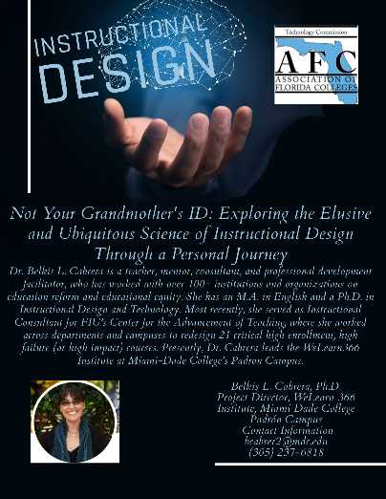
“Not Your Grandmother's ID: Exploring the Elusive and Ubiquitous Science of Instructional Design Through a Personal Journey”
Are you ready for the meta-version of Instructional Design? The field of ID has morphed and continues to morph over the past decade with the last five years representing a tremendous leap. To date, there are countless definitions, systems, structures, and programs encapsulated in ID. From education to business, from technologist to professional developer, the realm of the ID expert is vast and varied. Although there is some truth and validity in Wagner's (2011) argument about the secret handshakes of IDs, there is no denying that it has become increasingly difficult to recognize and explain the work and the skillsets of today's instructional designers. In this workshop, we will briefly examine the history of ID, explore definitions and terminology, and engage in conversations about the future of this elusive field/science/reality. We will also share our own ID journeys and our insights for building programs that effectively prepare the next generation of IDs.
- Links:
Technology Commission (myafchome.org)
AFC Calendar of Events Region 5

